

V 1.0
April 2026
Functional & Technical XStep Specification
SMPL: Retain Samples

Table of Contents
Functional Requirements 3
1 Purpose 3
2 Overview 3
3 Reasons for developing 4
4 Authorization 4
5 Assumptions/ Dependencies 5
6 Security Objects 5
7 Development Type 5
8 Processing Options 5
9 Functional Mapping Rules for Fields 6
10 Validation Checks 6
General Technical Specification 7
11 Technical XStep Layout Design 7
12 XStep Technical Specification 7
12.1 Parameters: 7
12.2 Development Architecture 11
12.3 Parameter Configuration 12
12.4 Technical Implementation 13
13 Function Module(s) 14
14 Pseudocode 15
15 Configuration Specifications 19
16 Test Scenarios 19
17 Document References 22
18 Revision History 22

Functional Item
Technical Item

Functional Requirements

Purpose
This document outlines the functional and technical design, along with the configuration specifications for the XStep “SMPL: Retain Samples”.

Overview
The SMPL: Retain Samples XStep allows operators to record and chart any samples retained from the process.

Functional Design
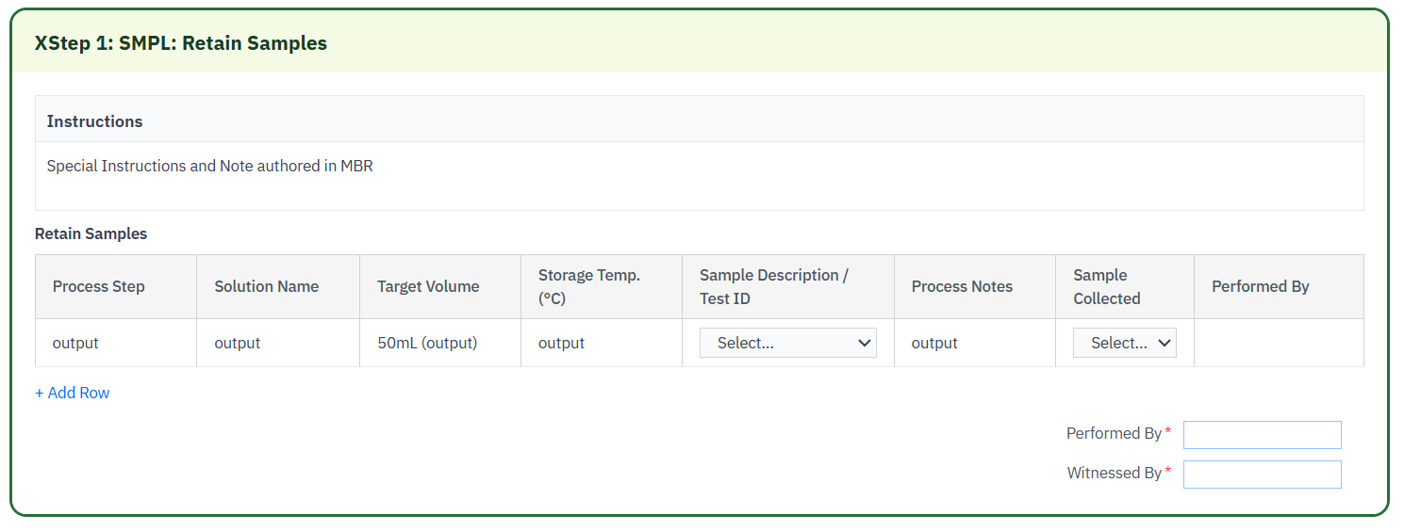

This step is comprised of a single large Retain Samples table, where users can view information for Process Step, Solution Name, Target Volume, Storage Temperature, and any Process notes. The target volume field should default to 50mL.
The other fields will be filled by <FUNCTION MODULE OR MBR PARAM>.
Using dropdown entries, users can input the Sample Description/Test ID and whether or not the sample was collected
The “Sample Description / Test ID” field will be a dropdown including the options “Bioburden” and “Cell Containing Bioburden”.
The “Sample Collected” field will be a dropdown for Yes/No.
After all relevant fields have been filled, users may enter their SAP user for the Performed by signature on each table row. Then, once all rows are signed, final Performed by and Witnessed by signatures can be entered at the bottom of the step to complete the step.

Reasons for developing
The SMPL: Retain Samples XStep was developed to record any and all retained samples.

Authorization
N/A

Assumptions/ Dependencies
 | Assumption
1 | Master Data has been set up correctly
2 | The function module is available, runs whenever an amount of cryoprotectant is added, and raises an error if validation is incorrect.

Security Objects
Object Name | Description
Signature validation | Optional

Development Type
Development Type: |  | Report |  | Interface |  | Conversion |  | Enhancement
 |  | Form |  | Workflow |  | Portal |  | EDI
 |  | Screen |  | Data Cleansing |  | Data Dependencies
 | X | Other: | XStep

Processing Options
Processing Options
Processing Mode: |  | Batch | X | Online
Frequency |  | Annually |  | Quarterly |  | Monthly |  | Weekly
 |  | Daily |  | Minutes
 | X | Other: | Executed per EBR

Functional Mapping Rules for Fields
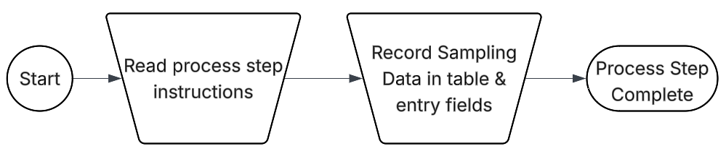

Validation Checks
Error Handling
Error | Action

General Technical Specification

Technical XStep Layout Design
Screenshot of Final Design

XStep Technical Specification

12.1 Parameters:
Screenshot of parameters page in Xstep

12.2 Development Architecture
The SMPL: Retain Samples XStep is developed to facilitate the entry and recording of retained samples.

12.3 Parameter Configuration
This XStep includes input and local parameters to manage content display, input validation and etc.
Configuration Parameters
- IV_HEADER (PPPI_SHORT_TEXT) – Configurable header text displayed at the top of the XStep via the SiMPL MBR
- IV_INSTR (PPPI_FRAGMENT_HTML) – Instructional content for operators, displayed under the header
- IV_ACTIVE / IV_ACT_FLP (ZSMPL_CHAR_YES_NO) – Controls whether the step is active and visible in execution
- IV_SIGN (ZSMPL_CHAR_SIGNATURE_STRAT) – Signature strategy to authorize and finalize equipment assignment
- IV_PRINT / IV_PL_TXT (PPPI_SHORT_TEXT / PPPI_FRAGMENT_HTML) – Controls print version and instruction print configuration
- IV_TITLE1 (PPPI_SHORT_TEXT) – Optional title for secondary display context
- IV_VERIFY (ZSMPL_CHAR_SIGNATURE_STRAT) – Optional verification signature strategy
- SIMPL_UUID (ZSMPL_CHAR_UUID) – Unique XStep identifier for traceability
- STEP_INDEX (PPPI_MATERIAL_QUANTITY) – Indicates the XStep’s position in the execution sequence

Output and Local Parameters
- LAV_ORDER (PPPI_PROCESS_ORDER) – Auto-filled with process order number
- LAV_PHASE (PPPI_PHASE) – Displays the current process phase
- LAV_PLANT (PPPI_PLANT_OF_BATCH) – Displays the production plant
- LAV_CRID (PPPI_CONTROL_RECIPE) – Displays the control recipe number
XStep Dependency Configuration
The following fields are used to link the dependency configuration in SiMPL MBR to the XStep structure:
- LV_LOCK(ZSMPL_CHAR_YES_NO) – Locking parameter
- EV_LOCK(ZSMPL_CHAR_YES_NO) - Output parameter that indicates locking decision
These parameters work in conjunction with the /SMPL/MBR_DEP_CHECK_ACTIVE function module, which checks to see if the current XStep has any dependencies. If there are any active dependencies linked to the XStep, the XStep will either be locked, or execution will be prevented, until the dependent step has been completed.
No additional setup is required from the XStep itself regarding the parameters listed above. The solution is already included for each XStep, so only the MBR configuration is required on the master recipe level for dependency information, if any inter-dependencies are needed throughout the PI Sheet.

12.4 Technical Implementation
Function Button Integration
Add description of button logic if any
Field Behavior and Flexibility
Add description of button logic if any
Signature Validation Mechanism
After the step is fully executed, operators are required to sign off using the configured signature strategy (IV_SIGN), confirming the assignment for audit and compliance purposes.
Applicability and Execution Control
- The IV_ACTIVE parameter determines whether the XStep is enabled during execution.
- The IV_ACT_FLP parameter ensures mutual exclusivity or alternate routing by acting as an inverse flag.
Data Integration and Traceability
- UUID-based tracking supports full traceability in the electronic batch record.
- Signature events are logged and auditable.
- Local parameters such as LAV_ORDER, LAV_PLANT, and LAV_PHASE are used to… If needed

Function Module(s)
Function: /SMPL/PPPI_FM_INITIAL_ACTIVE
Import Parameters:
Parameter Name | Associated Type | Short Text
IV_ACTIVE | CHAR1 | N/A

Export Parameters:
Parameter Name | Associated Type | Short Text
EV_ACTIVE | CHAR1 | N/A

Function: /SMPL/MBR_DEP_CHECK_ACTIVE
Import Parameters:
Parameter Name | Associated Type | Short Text
IM_CONTROL_RECIPE | POC_DOCID | N/A
IM_PHASE | VORNR
IM_AUFNR | AUFNR
IM_STEP_UUID | /SMPL/MBR_SOG_UUID
IM_PLANT | WERKS_D

Export Parameters:
Parameter Name | Associated Type | Short Text
EV_ACTIVE | CHAR1 | N/A

Exceptions:
Exception | Short Text
CONTROL_RECIPE_INITIAL

Pseudocode

Function: /SMPL/PPPI_FM_INITIAL_ACTIVE
1. Initialization
a. Input parameter IV_ACTIVE is optionally provided by the calling logic.
b. Constants gc_yes, gc_no, and gc_inside_range are assumed to be defined globally in the context of the function module.
2. Active Flag Evaluation
a. The function checks if the input value IV_ACTIVE falls within the expected valid range, represented by gc_inside_range.
b. Based on the result:
- If the input value is not equal to gc_inside_range, the XStep is marked as inactive by setting EV_ACTIVE = gc_no.
- If the input value is equal to gc_inside_range, the XStep is marked as active by setting EV_ACTIVE = gc_yes.
3. Output Assignment
a. The evaluated result is returned in the EV_ACTIVE export parameter for use by the calling logic (e.g., XStep configuration, PI sheet rendering).
Additional Notes
- This is a simple normalization function that abstracts how activation flags are interpreted for PPPI XSteps
- The use of constants (gc_yes, gc_no, and gc_inside_range) allows the logic to be aligned with broader application settings or standards.
- Helpful in scenarios where input values may vary but need to result in consistent "active" or "inactive" behavior.
- Input is optional, so defaulting behavior can be configured outside this function.
- This function improves clarity and consistency in determining whether an XStep should be active when rendered in the PI Sheet.

Function: /SMPL/MBR_DEP_CHECK_ACTIVE
1. Initialization
a. Input parameters provide context for determining whether an MBR (Manufacturing Batch Record) step can be activated:
- IM_CONTROL_RECIPE (POC_DOCID) – Control recipe ID identifying the batch instruction.
- IM_PHASE (VORNR) (Optional) – Operation or phase within the process order.
- IM_AUFNR (AUFNR) (Optional) – Process order number associated with the step.
- IM_STEP_UUID (/SMPL/MBR_SOG_UUID) – Unique step identifier (SOG).
- IM_PLANT (WERKS_D) – Plant code for process context.
b. The function first validates that IM_CONTROL_RECIPE is not initial.
- If it is initial, the exception CONTROL_RECIPE_INITIAL is raised.
c. Internal data is initialized:
- lt_ord_sigs: Internal table for storing order signature data from /SMPL/MBR_OR_SIG.
- ls_step_dep: Work area for step dependency data.
- Routine LOAD_INTERNAL_DATA is called to populate internal buffers (g_ord_data-t_ord_deps) using IM_AUFNR, IM_CONTROL_RECIPE, and IM_STEP_UUID.
2. Signature Data Retrieval
a. The function retrieves signature records for the process order from database table /SMPL/MBR_OR_SIG.
b. Selected fields include: AUFNR, SOG_UUID, TYPE, CREATED_DATE, CREATED_TIME, DEST_NAME, SIGN_ID, SIGN_DATE, and SIGN_TIME.
c. Only signatures related to the specified order (AUFNR = IM_AUFNR) are selected.
d. These records are stored in the internal table lt_ord_sigs for later evaluation.
3. Dependency Evaluation
a. The function loops through dependencies in g_ord_data-t_ord_deps where:
- TARGET_UUID = IM_STEP_UUID, and
- DEP_RULE is either gc_perform_before_start_rule or gc_verify_before_start_rule.
b. For each dependency record:
- If the rule is PERFORM BEFORE START, it checks whether the prerequisite step (PREREQ_UUID) has a pending perform signature (gc_perform_signature) with SIGN_ID = abap_false.
- If the rule is VERIFY BEFORE START, it checks whether the prerequisite step (PREREQ_UUID) has a pending verify signature (gc_verify_signature) with SIGN_ID = abap_false.
c. If an incomplete signature is found, the step is marked inactive (EV_ACTIVE = gc_step_inactive).
d. If all prerequisite signatures are complete, the step is marked active (EV_ACTIVE = gc_step_active).
4. Output Assignment
a. The evaluated activation status is returned in the export parameter EV_ACTIVE.
- gc_step_active – All prerequisite steps are completed; the current step can start.
- gc_step_inactive – At least one prerequisite step is incomplete; the current step remains blocked.
Additional Notes
This function determines whether a dependent step in a Manufacturing Batch Record is eligible to start based on the completion of prerequisite steps.
Key Features:
- Evaluates Perform Before Start and Verify Before Start dependency rules.
- Dynamically validates signature data from /SMPL/MBR_OR_SIG.
- Integrates with existing MBR dependency structures via global table g_ord_data-t_ord_deps.
Error Handling:
- Raises CONTROL_RECIPE_INITIAL if the control recipe input is missing.
- Handles empty dependency or signature data without runtime errors.
Dependencies:
- Tables: /SMPL/MBR_OR_SIG (Signatures), g_ord_data-t_ord_deps (Step Dependencies).
- Constants: gc_perform_before_start_rule, gc_verify_before_start_rule, gc_perform_signature, gc_verify_signature, gc_step_active, gc_step_inactive.
- Routine: LOAD_INTERNAL_DATA for initializing order context.
Assumptions:
- All prerequisite steps are recorded in the dependency table.
- Signature records are current and synchronized with MBR step progression.
Activation status is recalculated each time the function is called to reflect live signature data.

Configuration Specifications
N/A

Test Scenarios
Variant 1: Equipment Select
# | Scenario | Expected Result | Actual Result | Pass/ Fail
1 | Create and Release a Process Order with the pre-configured SiMPL Master Recipe and the relevant Production Version | Process Order created and Released containing SMPL: Retain Samples | Process Order created and Released containing SMPL: Retain Samples
2 | Open the EBR and navigate to Phase 0030 and then navigate to SMPL: Retain Samples | The EBR for the selected Process Order and Control Recipe opens successfully without any errors and the SMPL: Retain Samples step is visible in Phase 0030 | The EBR for the selected Process Order and Control Recipe opens successfully without any errors and the SMPL: Retain Samples step is visible in Phase 0030
3 | Expand “Sample Description / Test ID” dropdown | Options contain “Bioburden”, “Cell containing bioburden”

Document References
Reference No. | Document Title
Number used in superscript for reference | Full name of referenced document
1 | SiMPL Functional Guide: Universal Concepts

Revision History
Version No. | Description | Author | Date
1 | Initial Functional Design Information | Martin Van Laethem | April 24, 2026
1.1 | Technical Design Information | NAME | DATE

